
September 2025

Summary
Local board feedback on the Metropolitan Servicing Strategy
Watercare is developing a Metropolitan Servicing Strategy for water and wastewater to help guide our long-term infrastructure investments. This is a step towards providing safe, resilient, and affordable water and wastewater services for Watercare’s metropolitan servicing area for the next 70+ years.
To support this, Watercare has established an engagement process to involve communities and stakeholders in shaping how Auckland’s water and wastewater services will need to evolve to meet future challenges. The timeline and process for this engagement are outlined below:
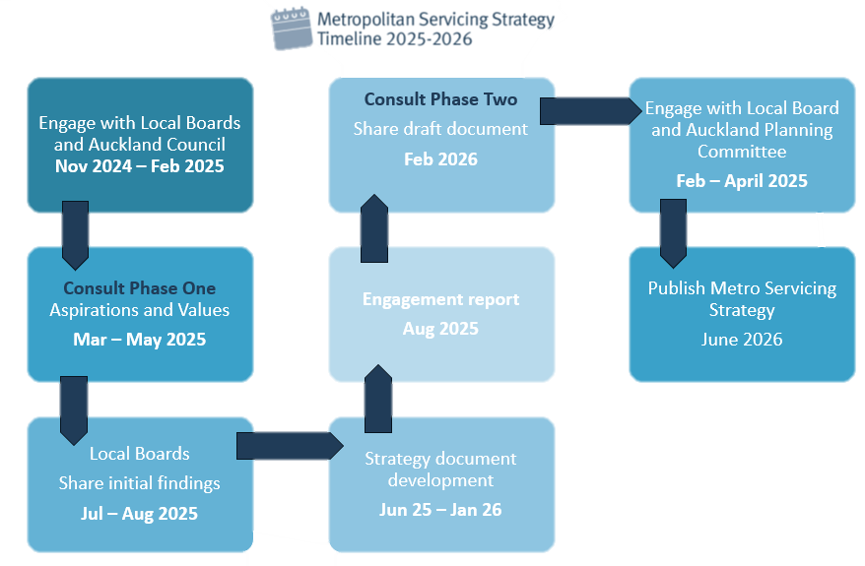
Public engagement on the aspirations and values underpinning the strategy took place from 25 March to 1 June 2025. This initial phase aimed to gather early insights into the values, aspirations, and considerations Aucklanders want reflected in the decision-making framework.
Following this, Watercare engaged with local boards to share feedback received from their communities and to seek their perspectives. This report outlines the formal feedback provided by local boards. This feedback will be used in the next phase to inform the Strategy document development.

Contents
Devonport-Takapuna Local Board 4
Henderson-Massey Local Board 5
Kaipātiki Local Board 6
Māngere-Ōtāhuhu 7
Puketāpapa Local Board 9
Waitākere Ranges Local Board 10
Waitematā Local Board 11
Whau Local Board 12
Upper Harbour Local Board 13

Devonport-Takapuna Local Board
Resolution number DT/2025/85
That the Devonport-Takapuna Local Board:
- whakaae / approve the following feedback on Watercare’s Wastewater Network Strategy:
  - tautoko / support for the necessary legislative and regulatory changes to enable water recycling and beneficial biosolids reuse.
  - tautoko / support for investigation into alternative water sources for Auckland, specifically highlighting the need for a water source located in the North of Auckland.
  - tautoko / support for increased facilitation by Auckland Council and CCO’s for private rainwater collection to increase the resilience of the water supply.
  - tuhi tīpoka / noting the increase in cultural diversity in the communities with varied viewpoints on drinking water and wastewater services. Support further efforts to engage and include these diverse viewpoints.
  - tautoko / support Watercare Services education programmes for new migrants on the North Shore. These should include information relating to drinking water, wastewater and toilet flushing etiquette (flush only pee, poo and paper).
  - tautoko / support Water Care Services education for senior populations on the North Shore regarding water use.
  - tono / request greater emphasis on servicing in high density areas.
CARRIED

Henderson-Massey Local Board
Resolution number HM/2025/120
That the Henderson-Massey Local Board:
- whakamihi / thank Watercare for engaging with communities on the Metropolitan Servicing Strategy and for presenting at the recent workshop.
- tautoko / support Watercare’s leadership in sustainability and innovation, including the exploration of alternative water sources such as desalination and purified recycled water.
- kohuki / consider that for the future management of biosolids there is a need for clear criteria to assess suitable locations for their disposal or reuse, including consideration of options within and outside the Auckland region.
- kohuki / consider that it is very important to address aged infrastructure alongside future growth.
- kohuki / consider that there is a need for increased investment and long-term planning to ensure the network can meet both current and future demands.
- tautoko / support stronger community education and awareness around the value of water as a taonga, including the need to shift public attitudes toward water use and wastewater through storytelling and engagement.
- tautoko / support the Metropolitan Servicing Strategy to remain a living document, with regular updates and opportunities for continued community input.
CARRIED

Kaipātiki Local Board
Resolution number KT/2025/450
That the Kaipātiki Local Board:
- tuku / provide the following feedback on Watercare’s Wastewater Network Strategy:
  - taukoko / support the necessary legislative and regulatory changes to enable water recycling and beneficial biosolids reuse.
  - taukoko / support engaging with government on the key issues so that the necessary legislation and regulatory framework is in place to allow solutions to future problems.
  - tautoko / support increased facilitation by Auckland Council and CCOs for private rainwater collection to increase the resilience of the water supply.
  - taukoko / support ongoing research and development of desalination technology to enable a wider variety of water sources for future generations and improve the future system's resilience.
  - taukoko / support Watercare Services providing greater education to the public on factors that contribute to wastewater overflows, noting that this is consistently one of the most important issues of concern for Kaipātiki residents.
  - tautoko / support further efforts to engage and provide more translated information to our community, noting the increase in cultural diversity in the community, with varied viewpoints on drinking water and wastewater services.
  - tautoko / support Watercare Services education programmes for new migrants on the North Shore. These should include information relating to drinking water, wastewater and toilet flushing etiquette (flush only pee, poo, and paper).
  - tono / request greater emphasis on servicing in high density areas.
  - tono / request enhanced monitoring to support early detection of contaminants and enable more responsive asset management of ecologically significant/sensitive Kaipātiki catchments.
  - tono / request increased collaboration and support for community-led initiatives funded by the local board for stream restoration and biodiversity preservation, for example, to enable Kaipātiki Project/ Pest Free Kaipātiki to enhance efforts with better outcomes.
  - tono / request an increase in preventative maintenance schedules for aging assets and high-risk zones in Kaipātiki, for example, Wairau catchments.
  - tono / request that the local board is kept informed about asset condition and performance, fault response times and reported environmental issues (contamination), noting that local board members often get information from social media rather than through official channels.
CARRIED

Māngere-Ōtāhuhu
Resolution number MO/2025/130
That the Māngere-Ōtāhuhu Local Board:
- whakamihi / thank Watercare for engaging the diverse communities of the Māngere-Ōtāhuhu Local Board rohe on the Metropolitan Servicing Strategy
- tuhi tīpoka / note that Watercare is developing the strategy to guide long-term water and wastewater planning, with finalisation scheduled for June 2026
- āhukahuka / acknowledge the reliable delivery of safe drinking water and wastewater services and the strong community trust in Watercare
- express concern about ageing infrastructure and slow repair response times, and request prioritisation of proactive maintenance and timely renewal of underground assets, particularly in rapidly growing areas
- highlight community concerns about odour and environmental impacts from the Māngere Wastewater Treatment Plant and possible changes to treatment of bio-solids in the local board area, and recommend that Watercare:
  - explore decentralised treatment options
  - improve odour management (including tree planting)
  - ensure equitable distribution of wastewater facilities
  - consider appropriate reparation for decades of odour impacts experienced by the community
- tautoko / support stronger investment in public education and transparency, particularly for youth and Pacific communities, on water conservation, leak detection, and water-cycle understanding
- ohia / endorse innovation and technology, ensuring it complements essential services, and encourage user-friendly tools for issue reporting, water recycling, rainwater tanks, and circular economy solutions
- tuhi tīpoka / note affordability concerns and request consideration of subsidies or water-rate reductions for communities bearing infrastructure impacts
  - tuhi tīpoka / note community priorities for:
  - recycling and reusing water and resources
  - building long-lasting infrastructure
  - keeping costs affordable while improving efficiency
  - preparing Auckland for extreme weather events and request clear pathways in the strategy to address these
- tautoko / support active Māori and Mana Whenua input, and intergenerational engagement, in shaping water and wastewater decisions
- tono / request that Watercare prioritises local procurement to maximise economic benefits for the community
- tono / request clear articulation of Watercare’s values and aspirations to build alignment and trust with the community
- whakapūmau / reaffirm the board’s belief that water is a taonga, and emphasise the need for the Strategy to provide long-term stability and protection that goes beyond shifts in political direction, ensuring consistent outcomes for community wellbeing, the environment, and intergenerational equity.
CARRIED

Puketāpapa Local Board
Resolution number PKTPP/2025/46
That the Puketāpapa Local Board:
a) note that it is important to investigate a range of technological solutions to the issue of biosolids, as there are many innovative solutions being developed overseas.
b) note that for the disposal of treated wastewater, it is important that an option for consideration is a discharge into the Tasman Sea to bypass the Manukau Harbour.
c) note that as a solution for the provision of a future water source, it is important that recycled water is a consideration.
d) note that water efficiency and demand management is an important part of the conversation.
e) note that further investigation into non-potable water supply for purposes/industries that do not need water treated to drinking water standard, is important to maximise drinking water supply.
f) support further investigation into the benefit of decentralisation and neighbour level solutions.
CARRIED

Waitākere Ranges Local Board
Resolution number WTK/2025/114
That the Waitākere Ranges Local Board:
- whakamihi / thank Watercare for engaging the diverse communities of the Waitākere Ranges Local Board rohe on the Metropolitan Servicing Strategy.
- tuku / provide feedback on the key issues outlined in Watercare’s Metropolitan Servicing Strategy
- whakawhetai / thank Watercare for attending the workshop and presenting on the Metropolitan Servicing Strategy.
- tuhi / note the Board’s opposition to consideration of new dams in the Waitākere Ranges, given the protections under the Deed of Acknowledgment.
- tono / request Watercare provide further information on how Auckland’s water and wastewater activities impact the harbour environment.
- tohutohe / encourage Watercare to prioritise public education on Auckland’s drinking water and wastewater systems, as opportunities to engage the wider community and promote environmental benefits, for example the proposed education displays at the restored Nihotupu Filter Station and an extension to the schools education programme.
- tono / request that Watercare strengthen engagement with mana whenua, Pasifika communities, local communities and industry stakeholders as part of developing the strategy.
CARRIED

Waitematā Local Board
Resolution number WTM/2025/129
That the Waitematā Local Board:
a) whakarite / provide following feedback on Watercare’s Wastewater Network Strategy.
  - Early and adequate investment in preparedness for extreme weather and other climate change effects.
  - Positive use should be made of biosolids and other wastewater products,
  - Eliminating stormwater and wastewater overflows into streams and harbours should be a priority.
  - Households, businesses and institutions should be encouraged and enabled to make greater use of grey water, including tank water.
  - All Watercare investments should represent long-term sustainable value for money.
  - for future major water sources, the use of purified recycled water should be investigated as a priority, along with further use of the Waikato River and the Riverhead Forest area.
CARRIED

Whau Local Board
Resolution number WH/2025/96
That the Whau Local Board:
- whakamihi / thank Watercare for engaging the diverse communities of the Whau Local Board rohe on the Metropolitan Servicing Strategy.
- tautoko / support ongoing planning for a new drinking water source for Tāmaki Makaurau beyond 2040, recognising the long lead-in times required for large-scale infrastructure investment.
- tono / request further investigation into the development of additional dam sites, as well as the potential expansion of Auckland’s existing dams, to ensure adequate future water storage capacity, recognising that approximately 20 per cent of Auckland’s current water supply is sourced from the Waitākere Ranges.
- tautoko / support further investigation into alternative drinking water source options, including purified recycled water and desalination, noting that central government policy does not currently recognise these options as potable water sources.
- tautoko / support adopting new technologies to recycle wastewater and reduce waste, noting that approximately 86 per cent of Auckland’s wastewater is treated and discharged into the Manukau Harbour.
- tono / request investigation into the establishment of a sustainable initiative rebate scheme aimed at reducing pressure on public infrastructure and utilities, while enhancing water resilience, e.g through the use of stormwater retention and rainwater collection tanks.
- tono / request that climate change impacts on river-based water sources be explicitly considered in future source planning, including the need for rain-independent options.
- tono / request enhanced community education and engagement on water efficiency, with a particular focus on demand management and behaviour change.
CARRIED

Upper Harbour Local Board
Resolution number UH/2025/127
That the Upper Harbour Local Board:
a) tuku / provide the following feedback on Watercare’s Metropolitan Servicing Strategy:
  - note community concern around the reuse of wastewater the board consider this a potential solution for non-potable water supply
  - support the need to expedite a solution for biosolids in the immediate future
  - consider that many parts of Auckland’s North Shore have a lack of resiliency for drinking water and request that this is addressed.

CARRIED

